Breeana Ashkar

Web Design Profile

1. Milton Glaser

2a. Glaser is best known for creating the iconic I <3 NY logo. He’s created designs for New York Magazine, The School of Visual Arts, Esquire Magazine, Brooklyn Brewery, Julliard, Sony, The Metropolitan Opera, and much more.

2b. Once he graduated from Cooper Union, he founded Push Pin Studios in 1954. He’s been involved with Graphic Design for over 60 years.

2c. Glaser remains engaged with the world and constantly thinks about changes happening in style and themes over the years, in order to keep designs up to date.

2d. Glaser doesn’t like using computers for design; he’d much rather hand draw. His skills are minimal with the computer.

2e. Glaser draws inspiration from a wide array of artists ranging from Picasso and Morandi to Herbert Bayer and George Salter.

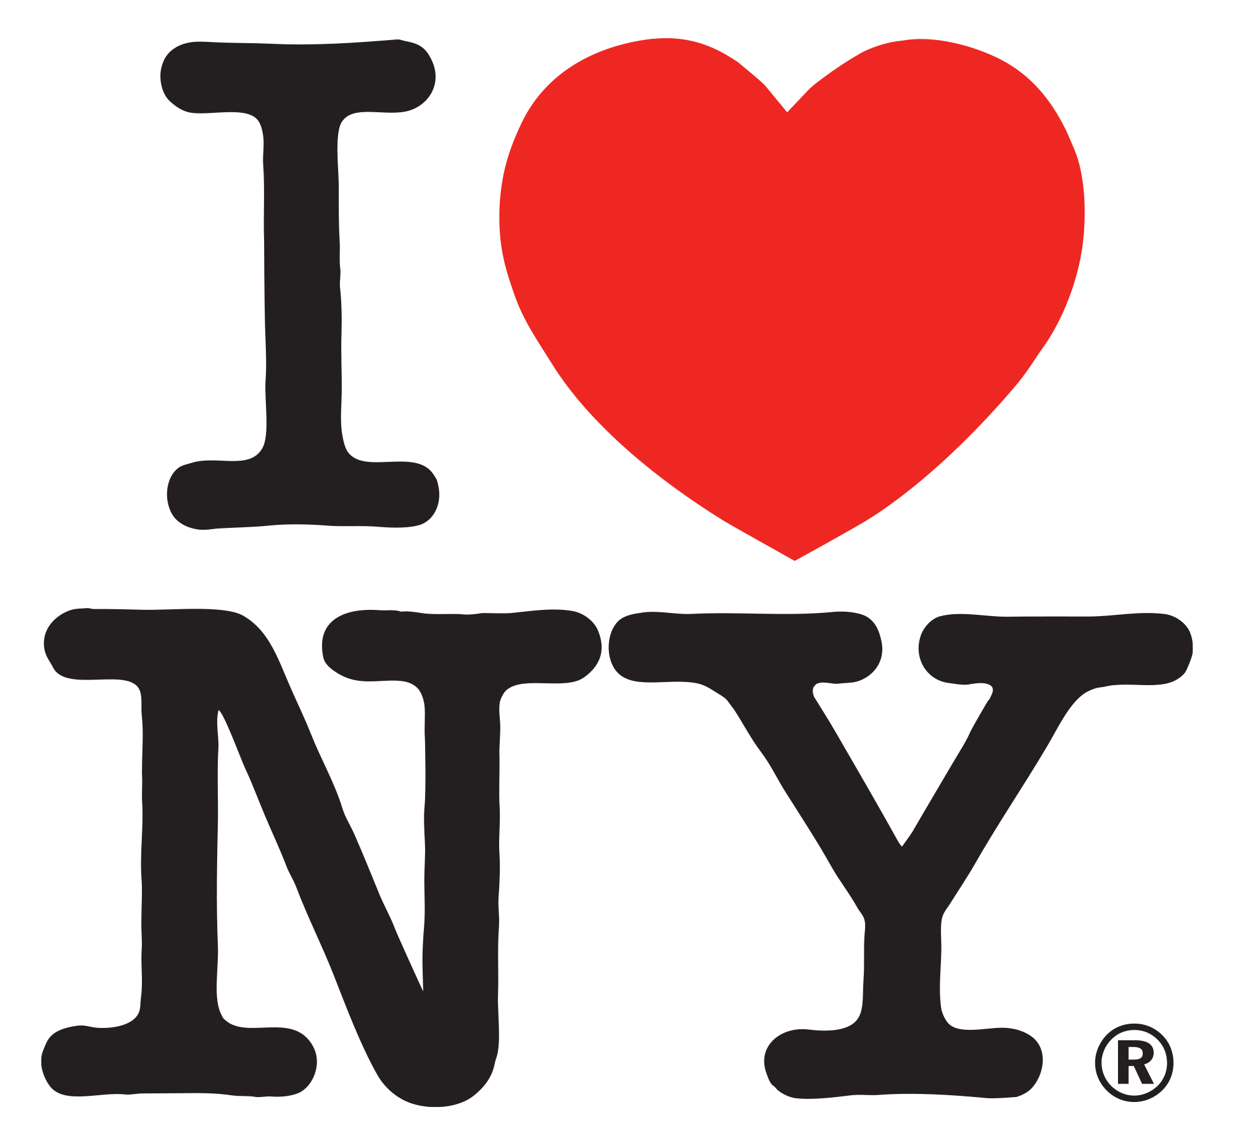

3a. Glaser is most famous for his I <3 NY logo. With this simple design, Glaser created an icon for New York City. Tourists and people visiting feed into the stereotype that is Times Square and eventually created a commercial empire around it.

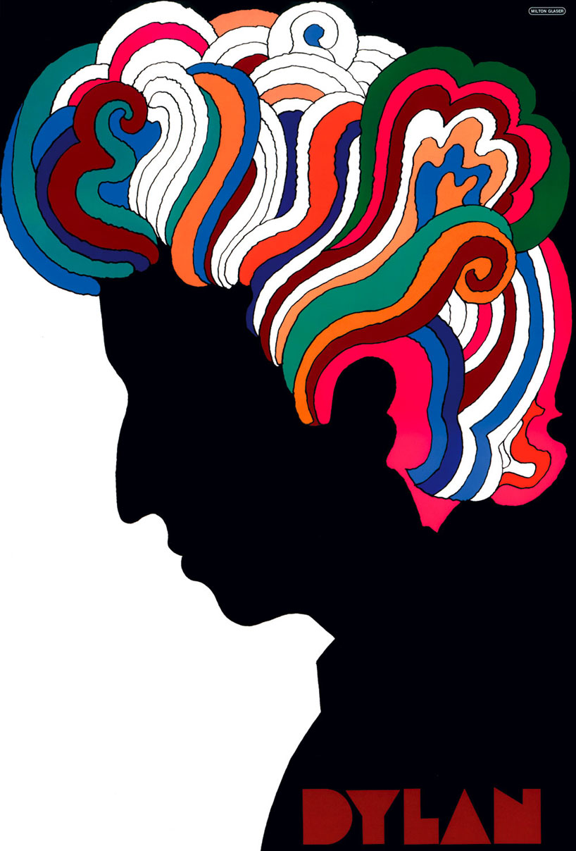

3b. Glaser’s famous Bob Dylan poster is one of my personal favorites. The design and color accurately capture the 70’s era- simple and colorful. Bob Dylan’s music and the simple design of the poster mesh together nicely. The smooth look and block letters on the bottom emulate Dylan’s style.

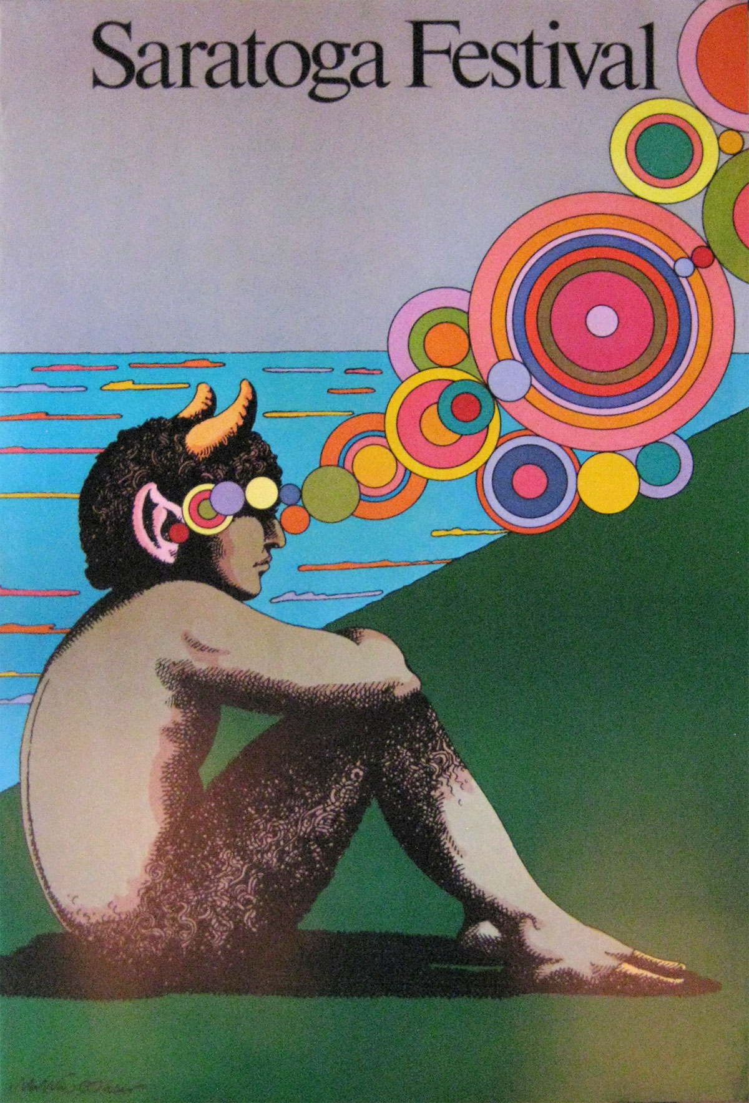3c. The Saratoga Festival poster embodies the overall theme of Glaser’s work, which is majority flat and simple, but always with a pop of color. The bright circles create a very flat dimension to the poster but at the same time move my eye across the page. Also, the lack of information and detail on the poster maintains the simple layout.